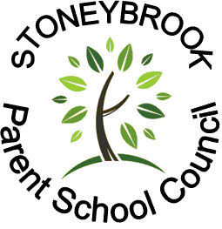
Tickets 5 for $1
or 25¢ each



Calling all Volunteers & Donations:

Food Safety is important! Please follow the school’s nut-safe guidelines & kindly label your baked goods with a list of ingredients.

We need your super creative, tasty & fun donations!
Be creative & think outside the ’cake box’. Consider a wide range of ’treats’... cookies, cupcakes, boxed chocolates, small denomination gift cards (iTunes, Cineplex, Tim Horton's, Marble Slab, Kernels etc.).

Donations should be delivered to the front foyer on
Friday, Feb. 12th between 8:30 and 9:00 a.m.
Kindly box, bag and/or cover for easier transportation home by the lucky winners.

Cake Day is a Stoneybrook tradition where students can purchase tickets

to win their favourite, mouth-watering goodies and fun items.

How do you win?
Tickets will be sold in each classroom Friday, February 12th.

Students will then be given the opportunity to view the ‘tasty treats’, and drop their
tickets in the box of the goodie that tempts them the most.
Enter as many times as you’d like to increase your chances of winning, but remember you can only win once.

The draw begins at 3:00 pm, when the lucky winners will be
announced & invited to the gymnasium to collect their ‘sweet reward’.

Volunteers are needed to help us with various small jobs during the day please!

Need help getting your cake to school?
Call us -we’ll pick it up the night
before & get it there for you!

If you have any questions or have an hour of time to share, please contact
Tania Testa at 519-636-7358, or
volunteer@stoneybrookpsc.ca .

Thank you for your support!
A Stoneybrook Parent School Council Initiative - info@StoneybrookPSC.ca

Friday, February 12th
A Stoneybrook Parent School Council Initiative - info@StoneybrookPSC.ca

